Chapter 11, Problem 65.

In the op amp circuit of Fig. 11.84, v_{s} = 4 cos 10⁴ t V. Find the average power delivered to the 50-kΩ resistor.

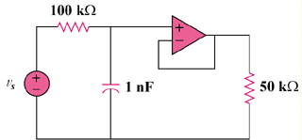

Figure 11.84
For Prob. 11.65.

